H.T No
Regulations:
A18

Sreenidhi Institute of Science and Technology
(An Autonomous Institution)
Code No: 7F302 Date: 06-Oct-2020 (FN)

B.Tech II-Year I-Semester External Examination, October - 2020 (Supplementary)
DISCRETE MATHEMATICS (CSE and it)

Time: 2 Hours Max.Marks:70

Note: a) No additional answer sheets will be provided.
b) All sub-parts of a question must be answered at one place only, otherwise it will not be valued.
c) Missing data can be assumed suitably.

ANSWER ANY FIVE QUESTIONS. EACH QUESTION CARRIES 14 MARKS.

1. | a) | Prove that [(p→r)˄(q→r)] →[(p˅q)→r] is a tautology. | [7M]
 | b) | State and explain the rules that can generate a well formed formula. | [7M]
2. | a) | Prove or disprove the validity of following arguments using rules of inference.  All naughty kids are intelligent.  All boys are naughty.  Therefore all boys are intelligent. | [7M]
 | b) | Prove that the following argument is valid:  ¬∃x (p(x)˄ q(x))  P(a)  ∴¬q(a) | [7M]
3. | a) | Let G={-1,0,1} verify whether G forms a group under usual multiplication. | [7M]
 | b) | Prove that relation a congruent to b mod H is an equivalence relation. | [7M]
4. | a) | Find midterm of (3x-1/x)⁸. | [7M]
 | b) | Find the term which contains x¹¹ and y⁴ in expansion of (3x³ +2xy² +z³)⁵ . | [7M]
5. | a) | Solve a_{n+2} -6a_{n+1} + 9a_{n} = 3.2^{n} +7.3^{n} for n>=0 where a₀=1,a₁=4. | [7M]
 | b) | Using generating function find a_{n} in terms of a if a₀=1 ,a₁=2 and a_{n+2}=5a_{n+1}-4a_{n} for n>=0. | [7M]
6. | a) | Determine whether given pair of graphs is isomorphic.  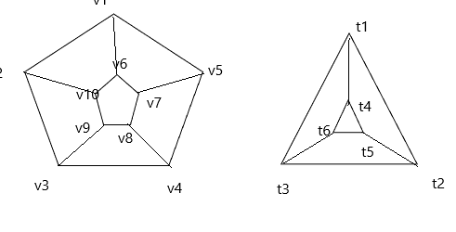 | [7M]
 | b) | What is Euler circuit or path? How do you determine whether a graph has Euler circuit. | [7M]
7. | a) | Explain about well formed formulas with on example. | [7M]
 | b) | Find the PCNF of the following: i) ~P^Q ii) ~(P→Q) | [7M]
8. | a) | Discuss in detail about automatic theorem proving. | [7M]
 | b) | Explain about Free and Bound variables. | [7M]

-- 00 -- 00 –

